H.T No
Regulations:
A18

Sreenidhi Institute of Science and Technology
(An Autonomous Institution)
Code No: 7HC16 Date: 29-Jan-2025 (AN)

B.Tech II-Year II- Semester External Examination, January-2025 (Supplementary)
MATHEMATICS-II (Differential Calculus) - (CSE, IT and ECM)

Time: 3 Hours Max.Marks:70

Note: a) No additional answer sheets will be provided.
b) All sub-parts of a question must be answered at one place only, otherwise it will not be valued.
c) Missing data can be assumed suitably.
Bloom's Cognitive Levels of Learning (BCLL)

Remember | L1 | Apply | L3 | Evaluate | L5
Understand | L2 | Analyze | L4 | Create | L6

Part - A Max.Marks:20

Answer all QUESTIONS.

 |  | BCLL | CO(s) | Marks
1 | Define Jacobian two variables’ formulae. | L1 | CO1 | [2M]
2 | Write Bernoulli’s Equation. | L2 | CO2 | [2M]
3 | Find Particular Integral | L2 | CO3 | [2M]
4 | Write Lagrange’s interpolation formula. | L1 | CO4 | [2M]
5 | Write Picard’s formula. | L1 | CO5 | [2M]
6 | Find  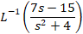 | L2 | CO6 | [2M]
7 | Define functional dependence | L1 | CO1 | [2M]
8 | Write Cauchy-Euler equation | L1 | CO3 | [2M]
9 | Find | L1 | CO6 | [2M]
10 | Write Newton -Raphson formula | L1 | CO5 | [2M]

Part – B Max.Marks:50
ANSWER ANY FIVE QUESTIONS. EACH QUESTION CARRIES 10 MARKS.

 |  |  | BCLL | CO(s) | Marks
11. | a) | Discuss the continuity of the function 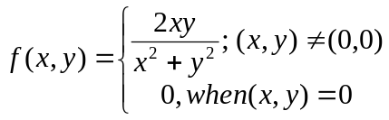 | L2 | CO1 | [5M]
 | b) | Define limit of the function of two variable with atleast one example. | L2 | CO1 | [5M]
12. | a) | 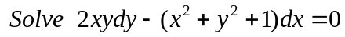 | L3 | CO2 | [5M]
 | b) | A body kept in air with temperature 25ºc cools from 140ºc to 80ºc in 20 minutes. Find when the body cools down to 35ºc. | L2 | CO2 | [5M]
13. | a) | Solve (D²+D+1)y=Sin2x | L3 | CO3 | [5M]
 | b) | Solve (D²-1)y=e^{x}+x² | L3 | CO3 | [5M]
14. | a) | Obtain a root up to three decimal places of the given equation x³-4x-9=0; using the bisection method. | L2 | CO4 | [5M]
 | b) | Explain briefly the significant difference between Bisection method and Newton Raphson method. | L2 | CO4 | [5M]
15. | a) | Using Taylor’s series method, find an approximate value of y at x=0.2 for the differential equation 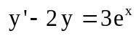 for y (0) = 0. | L2 | CO5 | [5M]
 | b) | Find y (0.1) using Runge-Kutta fourth order formula , given that 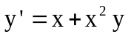 and y (0) =1 | L2 | CO5 | [5M]
16. | a) | Find | L2 | CO6 | [5M]
 | b) | Find  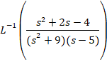 | L2 | CO6 | [5M]
17. | a) | If u = log 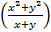 ,prove that x + y =1 | L2 | CO1 | [4M]
 | b) | Solve x | L3 | CO2 | [3M]
 | c) | Solve | L3 | CO3 | [3M]
18. | a) | From the following table of values of x and y, obtain for x=1.5 | L3 | CO4 | [4M]
  x | 1.5 | 2.0 | 2.5 | 3.0 | 3.5 | 4.0
  y | 3.375 | 7.0 | 13.625 | 24.0 | 38.875 | 59.0
 | b) | Using Euler’s Method find y(0.5) given taking h=0.1. | L2 | CO5 | [3M]
 | c) | Find  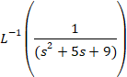 | L2 | CO6 | [3M]
-- 00 -- 00 –

